Autumn Holzinger Assignment 2

1.

A)

Using KVL and knowing current through a capacitor = C $\frac{dV\text{c(t)}}{dt}$, the total voltage will equal the sum of the voltages in the capacitor and resistor.

B)

Casual because the output only depends on present values of input.

Time invariant because First Order Differential Equation

Linear:

$RC\left[\frac{d}{dt}\left(a1*Vc1\left(t\right)+a2*Vc2\left(t\right)\right)\right]+a1*Vc1\left(t\right)+a2*Vc2\left(t\right)=a1V1\left(t\right)+a2V2\left(t\right)$

$a1[RC(\left[\frac{d}{dt}\left(Vc1\left(t\right)\right)+Vc1\left(t\right)-V1\left(t\right)\right]=a2[RC(\left[\frac{d}{dt}\left(Vc2\left(t\right)\right)+Vc2\left(t\right)-V2\left(t\right)\right]=0$

Since $RC(\left[\frac{d}{dt}\left(Vci\left(t\right)\right)+Vci\left(t\right)-Vi\left(t\right)\right]=0 when i=1,2$

Both parts equal 0 so it satisfies principle of superposition and is therefore linear

C)

$Vc\left(t\right)=u\left(t\right)-.5*.25(\frac{dVc\left(t\right)}{dt})$

$$when t>0$$

$$Vc\left(t\right)=1-0.125\left(\frac{dVc\left(t\right)}{dt}\right) 0=-0.125s need to add 1 to make this possible$$

$$so Vc\left(t\right)=Ce^{-8t}+1$$

When t < 0

$$Vc\left(t\right)=-0.125\left(\frac{dVc\left(t\right)}{dt}\right) 0=-0.125s-1 s=\frac{1}{.125}=8 so so Vc\left(t\right)=Ce^{-8t}$$

2.

A)

Casual because output doesn’t depend on input at a future time, only at a past time.

Time invariant

y(t)=x(t-1-t0) y(t-t0)= x(t-t0-1)=y(t)

linearity:

a1\*y1(t)+a2\*y2(t)=a1\*x1(t-1)+a2&x2(t-1)

a1[y1(t)-x1(t-1)]+a2[y2(t)-x2(t-1)]=0

since yi(t)-xi(t-1)=0 when i=1,2

Both parts equal 0 so it satisfies principle of superposition and is therefore linear

B)

$h\left(t\right)=\int_{-∞}^{∞}{x\left(t-1\right)dt=u\left(t-1\right) when t>1=1 when t<1=0}$

C)

$y\left(t\right)= \int_{-∞}^{∞}{h \left(τ\right)*x\left(t-τ\right)dτ= }\int_{-∞}^{∞}{h\left(τ\right)*e^{j\left(t-τ\right)}dτ=e^{jt}\int_{-∞}^{∞}{h\left(τ\right)e^{-jt}dτ=e^{jt}*h(t)}}$

3.

A)

$\frac{d}{dt}[y\left(t\right)=\int{\frac{1}{L}*x\left(t\right)-\frac{R}{L}*y\left(t\right)dt]=y'(t)= \frac{1}{L}*x\left(t\right)-\frac{R}{L}*y\left(t\right)dt}$

B)

Using KCL

$\frac{Vi\left(t\right)}{R}+\frac{CdVo\left(t\right)}{dt}=0 \frac{Vi\left(t\right)}{RC}=-\frac{dVo\left(t\right)}{dt} Vo\left(t\right)=-\frac{1}{RC}*\int_{-∞}^{∞}{Vi\left(t\right)dt}$

C)

$if R*C=1 then Vo\left(t\right)=-\int_{-∞}^{∞}{Vi\left(t\right)dt}$

$when you take acount for the inverting op amp, the sign gets changed to give the final answer$ $Vo\left(t\right)=\int_{-∞}^{∞}{Vi\left(t\right)dt}$

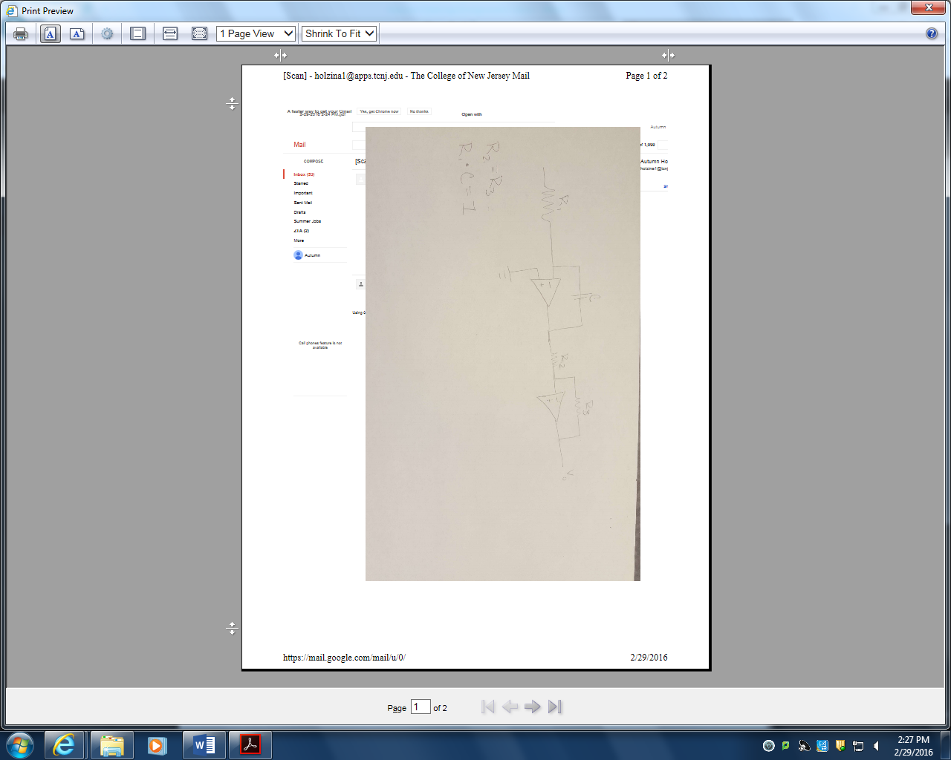

4.

A)

$y\left(t\right)=\int{(}\int{10x\left(t\right)-5y\left(t\right)-6\int{(y\left(t\right)dt)dt)dt}}$

$y^{\left(2\right)}\left(t\right)=10x\left(t\right)-5y\left(t\right)-6y'(t)$

B)

$y^{\left(2\right)}\left(t\right)+5y\left(t\right)+6y^{'}\left(t\right)=10x\left(t\right)$

$s^{2}+6s+5=0 => \left(s+1\right)\left(s+5\right)=0 => s=-1,-5$

5y(t)=10x(t) => 5s=10 => s=2

$yc\left(t\right)=2+c1e^{-1t}+c2e^{-5t}$

When y(0)=-1 $-1=2+$ c1+c2 -3=c1+c2

When y’(0)=0 $0=-c1-5c2 => c1=-5c2$

After solving $c2=\frac{3}{4} c1=-\frac{15}{4}$

$yc\left(t\right)=2-\frac{15}{4}e^{-1t}+\frac{3}{4}e^{-5t}$

C)

??????????????????????

D)

?????????????????????